

****Year 10 General Chemistry****

****Atomic structure and the periodic table****

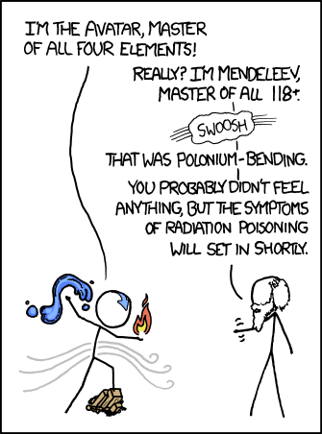

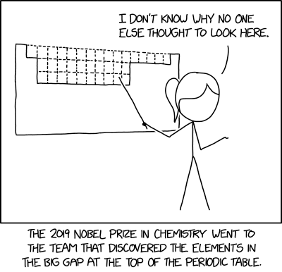

(Munroe, 2011)(Munroe, 2019)

**Name: SOLUTIONS**

## **Program**

|  |  |  |  |
| --- | --- | --- | --- |
| **W** | **L** | **Topic** | **Education Perfect Review** |
| 1 | 1 | Subatomic particles | The Structure of an Atom |
| 2 | Atoms | Atomic Symbols |
| 3 | Isotopes | What are Isotopes? |
| 4 | Representing isotopes |  |
| 5 | Electron shells |  |
| 2 | 1 | Electron dot diagrams |  |
| 2 | Electron configurations | Electron Configuration |
| 3 | Periodic table | The Periodic Table, Groups 1 and 2, Group 17, Group 18 |
| 4 | Ions | What are Ions? |
| 5 | Ionic, covalent or metallic |  |
| 3 | 1 | Writing ionic formulae | Ionic Compounds |
| 2 | Naming ionic substances | Naming Ionic Compounds |
| 3 | Writing covalent formulae |  |
| 4 | Naming covalent substances |  |
| 5 | Balancing equations | Reactants and Products: Reaction in Action, Writing Word Equations |
| 4 | 1 | Balancing equations | Writing Chemical and Molecular Equations, Balancing Equations |
| 2 | Revision | Writing Chemical Equations 1, Writing Chemical Equations 2 |
| 3 | Revision | Balancing Chemical Equations |
| 4 | **Mid-topic Test** |  |
| 5 | Interhouse Swimming Carnival |  |
| 5 | 1 | Labour Day |  |
| 2 | Collision theory | Extension: Collision Theory |
| 3 | Rate of reaction | Rate of Reaction |
| 4 | Test review |  |
| 5 | Carbon dioxide |  |
| 6 | 1 | Acid-carbonate reactions | Acid Reactions |
| 2 | Making carbon dioxide practical |  |
| 3 | Changing reaction rate - CO2 | Agitation, Concentration and Surface Area |
| 4 | Hydrogen |  |
| 5 | Acid-metal reactions | Metal Reactions with Acid |
| 7 | 1 | Making hydrogen practical |  |
| 2 | Changing reaction rate - H2 |  |
| 3 | Oxygen |  |
| 4 | Decomposition reactions | Combination and Decomposition Reactions |
| 5 | Making oxygen practical |  |

|  |  |  |  |
| --- | --- | --- | --- |
| 8 | 1 | Changing reaction rate - O2 | Activation Energy, Temperature and Catalysts |
| 2 | Factors affecting reaction rate | Extension: Factors Affecting Reaction Rates |
| 3 | Revision |  |
| 4 | **Reaction rates - Validation** |  |
| 5 | Revision |  |
| 9 | 1 | Revision |  |
| 2 | Test review |  |
| 3 | Revision |  |
| 4 | **Topic Test** |  |
|  | GOOD FRIDAY |  |

## **SCSA Curriculum Statements**

**T**he atomic structure and properties of elements are used to organise them in the Periodic Table (ACSSU186)

Different types of chemical reactions are used to produce a range of products and can occur at different rates (ACSSU187)

## **SCSA Judging Standards**

|  |  |
| --- | --- |
| **A** – Excellent Achievement | Uses the position of elements in the periodic table to determine their atomic structure and electron configuration, and makes predictions about bonding types and reactivity of elements.  Creates balanced chemical equations to predict the products of unfamiliar reactions.  Applies the particle model to explain how different factors influence the rate of reactions in terms of bonding. |
| **B** – High Achievement | Uses the position of elements in the periodic table to determine their atomic structure and electron configuration, and makes predictions about chemical properties and reactivity.  Creates balanced chemical equations for characteristic reactions and their products. Applies the particle model to explain how factors influence the rate of reactions in terms of collisions. |
| **C** – Satisfactory Achievement | Uses the position of elements in the periodic table to make some correct predictions about their observable properties.  Explains how chemical reactions produce particular products using word equations, and describes how some factors influence the rate of reactions. |

## **Assessment Outline**

|  |  |
| --- | --- |
| **Task** | **Weighting** |
| Mid-topic Test | 17% |
| Reaction Rates Validation | 18% |
| Topic Test | 25% |
| Exam | 40% |
| **Total** | **100%** |

## Glossary

|  |  |
| --- | --- |
| **Isotope** | atoms of an element with the same number of |
| protons but different numbers of neutrons |
| **Valence electrons** | electrons in the outermost shell of an atom |
|  |
| **Ion** | an atom that has gained or lost electrons to |
| achieve a full outer shell, leaving it charged |
| **Ionic compound** | a compound made of both metals and non-metals |
|  |
| **Covalent compound** | a compound made only of non-metals |
|  |

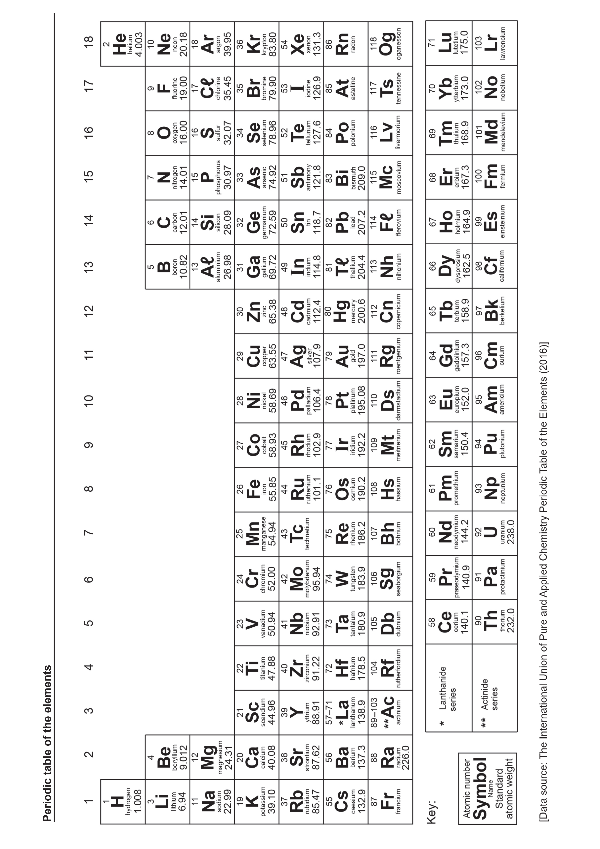

## Ions and molecules for year 10 General Chemistry

|  |  |  |  |
| --- | --- | --- | --- |
| +1 Charge | | -1 Charge | |
| hydrogen  lithium  sodium  potassium  silver  ammonium | H+  Li+  Na+  K+  Ag+  NH4+ | fluoride  chloride  bromide  iodide  hydroxide  nitrate  ethanoate (acetate)  hydrogen carbonate  hydrogensulfate | F-  Cl-  Br-  I-  OH-  NO3-  CH3COO-  HCO3-  HSO4- |
| +2 Charge | | -2 Charge | |
| magnesium  calcium  barium  zinc  strontium  cobalt (II)  manganese (II)  copper (II)  iron (II)  lead (II)  nickel (II) | Mg2+  Ca2+  Ba2+  Zn2+  Sr2+  Co2+  Mn2+  Cu2+  Fe2+  Pb2+  Ni2+ | oxide  sulfide  carbonate  sulfate | O2-  S2-  CO32-  SO42- |
| +3 Charge | | -3 Charge | |
| aluminium  iron (III)  chromium (III) | Al3+  Fe3+  Cr3+ | nitride  phosphate | N3-  PO43- |

|  |  |
| --- | --- |
| **Covalent compounds with specific names:** | |
| **Hydrochloric acid HCl**  **Ethanoic (acetic) acid CH3COOH**  **Nitric acid HNO3**  **Sulfuric acid H2SO4** | **Carbonic acid H2CO3**  **Water H2O**  **Ammonia NH3**  **Hydrogen peroxide H2O2** |

## Atomic Structure

An atom is the basic building block of all matter. It is made of smaller particles known as protons, neutrons, and electrons.

|  |  |  |  |
| --- | --- | --- | --- |
| **Particle** | **Charge** | **Mass** | **Position** |
| Proton | +1 | 1 | nucleus |
| Neutron | 0 | 1 | nucleus |
| Electron | -1 | 0.0005 | area around nucleus |

Protons and neutrons sit together in the center of the atom, this is known as the nucleus and it contains (almost) all the atom’s mass.

Electrons are outside the nucleus; they can be thought of as orbiting the nucleus. The electrons are arranged in layers known as shells or energy levels, these are responsible for most of an atom’s size.

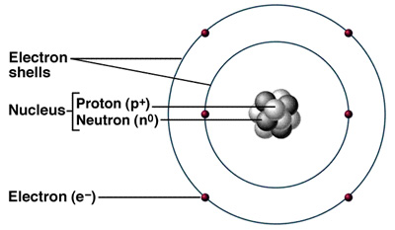

(atomic structure, 2013)

## Elements

Atoms with different numbers of protons have different chemical properties, these are known as different elements.

For example, any atom with 1 proton is known as the element hydrogen, while any atom with 6 protons is the element carbon.

The number of protons an atom has is known as its atomic number, different elements have different atomic numbers.

Each element is given its own symbol of one to two letters with the first letter capitalized. These symbols typically come from the name of the element but can be confusing if they have come from the old Latin or German name for the element.

For example hydrogen (1 proton) is H, gold (79 protons) is Au.

## Isotopes

Two atoms with the same number of protons can still have different numbers of neutrons. Since they have the same number of protons, they are the same element, but they will have different physical properties.

Isotopes are versions of an element with the same number of protons but with different numbers of neutrons.

The number of protons and neutrons an atom has is known as its mass number, different isotopes have different mass numbers.

## Referring to specific isotopes

When referring to a specific atom we need to specify how many protons and neutrons it has, this is commonly done in two ways:

In the first format, the larger number is the mass number (number of protons + neutrons). The smaller number is the atomic number (number of protons). The symbol can also be used to find the number of protons by referring to the periodic table.

C-12

In the second format, just the mass number is written after the symbol.

On the periodic table the atomic number for an element is written on top while the average mass number of its isotopes is written underneath.

6

**C**

12.01

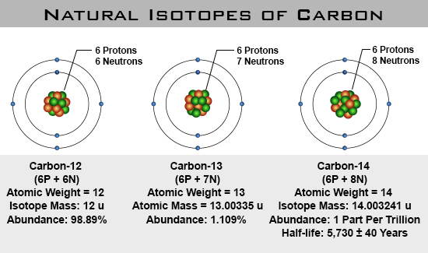

(Schmittner, n.d.)

**Examples**

|  |  |  |  |
| --- | --- | --- | --- |
| Isotope | Number of protons | Number of neutrons | Mass number |
|  | 6 | 6 | 12 |
| C-13 | 6 | 7 | 13 |
| C-14 | 6 | 8 | 14 |
|  | 17 | 18 | 35 |
|  | 17 | 20 | 37 |
| H-1 | 1 | 0 | 1 |
| H-2 | 1 | 1 | 2 |
| H-3 | 1 | 2 | 3 |

Draw labelled diagrams of the following atoms. Make sure you label the nucleus, protons, neutrons and electrons.

1. The C-13 isotope.

**+ = proton**

**N = neutron**

**N**

**N**

**N**

**N**

**N**

**+**

**+**

**+**

**+**

**X**

**X**

**X**

**X**

**X**

**+**

**N**

**N**

**+**

**X**

**X = electron**

**nucleus**

1. A lithium atom with a mass number of 7.

**+ = proton**

**N = neutron**

**N**

**N**

**+**

**+**

**X**

**X**

**X**

**+**

**N**

**N**

**X = electron**

**nucleus**

1. A chlorine atom with 18 neutrons.

**+**

**+**

**N**

**N**

**N**

**N**

**+**

**N**

**+**

**+**

**N**

**+**

**N**

**N**

**+**

**N**

**+**

**N**

**N**

**+**

**X**

**X**

**+ = proton**

**N = neutron**

**N**

**N**

**N**

**N**

**N**

**+**

**+**

**+**

**+**

**X**

**X**

**X**

**X**

**X**

**+**

**N**

**N**

**+**

**X**

**X = electron**

**nucleus**

**X**

**X**

**X**

**X**

**X**

**X**

**X**

**+**

**+**

## Electron Arrangement

The electrons in an atom are arranged in layers known as electron shells or electron energy levels.

* A neutral atom will have the same total number of electrons as protons.
* Each shell can hold a certain number of electrons.
* The shells fill up in order from the innermost shell outwards.
* No electrons can be added to a shell until the shells below it are full.

For the first 20 elements:

|  |  |
| --- | --- |
| **Electron shell** | **Maximum number of electrons** |
| 1st | 2 |
| 2nd | 8 |
| 3rd | 8 |
| 4th | 2 |

## Electron shell diagrams

The arrangement of electrons in an atom can be shown using an electron shell or electron energy level diagram.

The shells are drawn as concentric circles around the nucleus. Electrons are shown as dots or crosses on the shells.

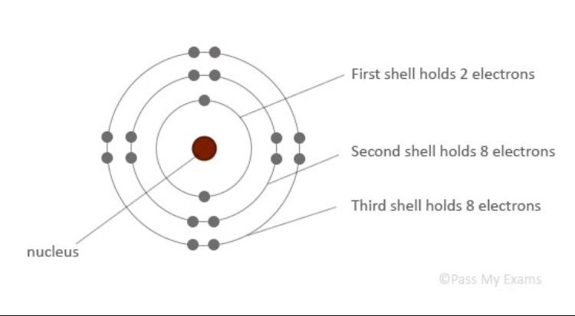

|  |  |
| --- | --- |
| Boron (B ) 5  B | Neon (Ne) 10  Ne |
| Beryllium (Be) 4  Be | Fluorine (F) 9  F |
| Lithium (Li) 3  Li | Oxygen (O) 8  O |
| Helium (He) 2  He | Nitrogen (N) 7  N |
| Hydrogen (H) 1  H  Draw the electron shell diagrams of the following elements. | Carbon (C) 6  C |
| Phosphorous (P) 15  P | Calcium (Ca) 20  Ca |
| Silicon (Si) 14  Si  Ca | Potassium (K) 19  K |
| Aluminium (Al) 13  Al | Argon (Ar) 18  Ar |
| Magnesium (Mg) 12  Mg | Chlorine (Cl) 17  Cl |
| Sodium (Na) 11  Na | Sulfur (S) 16  S |

## Electrons (Lewis) dot diagrams

In chemistry we are often most interested in the electrons in the outermost shell, these are known as valence electrons and the outermost shell is known as the valence shell.

Electron shell diagrams are space- and time-consuming to draw so the just the valence electrons can be shown using a Lewis dot or electron dot diagram.

The valence electrons are shown as dots or crosses around the symbol of the element. No circles are drawn.

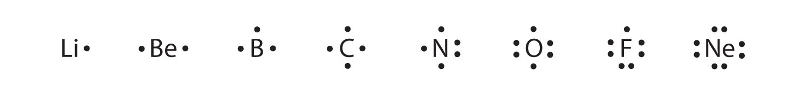

**Electron dot diagrams for ions**

Atoms can gain or lose electrons forming ions. This will give them a charge because they will have different numbers of protons and neutrons.

The ion’s diagram is written in square brackets with the charge shown in superscript after the brackets.

Positive ions – lose all valence electrons, will have no dots.

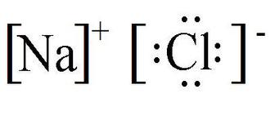

Negative ions – gain enough valence electrons to fill valence shell, will have 8 dots.

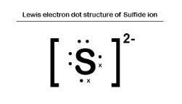

**Electron dot diagrams for ionic compounds**

Dot diagrams for ions written next to each other, positive ion first. Numbers added in front where more than one copy of an ion is needed.

e.g. lithium oxide Li2O aluminium chloride CaCl2

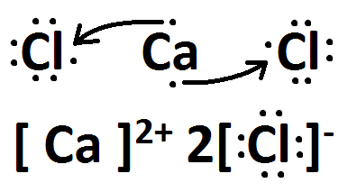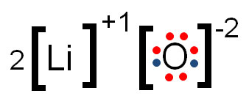

**Electron dot diagrams for molecules**

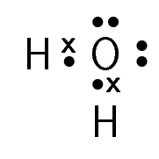**Atoms in molecules share electrons so one electron can count towards a full shell for two different atoms.**

**e.g. water H2O**

Draw electron (Lewis) dot diagrams for the following:

Mg Mg2+

Mg

Mg

2+

S S2-

S

2-

S

Cl2 O2

O

O

Cl

Cl

H2O MgCl2

Mg

2+

Cl

-

2

O

H

H

## Electron configurations

The third alternative for representing the arrangement of electrons in an atom is known as an electron configuration. The number of electrons in each shell are written in order, inside brackets, separated by commas.

e.g. C: (2,4) Ca: (2,8,8,2)

|  |  |  |  |  |
| --- | --- | --- | --- | --- |
| **Lewis Diagram** | He | N | Na | Ca |
| **Number of valence electrons** | 2 | 5 | 1 | 2 |
| **Electron configuration** | (2) | (2,5) | (2,8,1) | (2,8,8,2) |
| **Electron shell diagram** | He | N | Na | Ca |
| **Atomic number** | 2 | 7 | 11 | 20 |
| **Element** | He | N | Na | Ca |

## Periodic Table

The elements can be arranged in order of atomic number, then placed in rows based on the number of electrons shells they have, and columns based on how many valence electrons they have.

This arrangement can be refined by considering the properties of the elements and leads to the periodic table.

The columns are known as groups, the group number of an element is related to its number of valence electrons.

e.g. group 1 elements have 1 valence electron, group 13 elements have 3 valence electrons

The rows are known as periods, the period number of an element determines its number of electron shells.

e.g. period 3 elements have 3 electron shells

**Details**

* Elements in the top right-hand corner are non-metals, the rest are metals
* Group 1 elements are known as alkali metals
* Group 2 elements are known as alkaline earth metals
* Group 17 elements are known as halogens
* 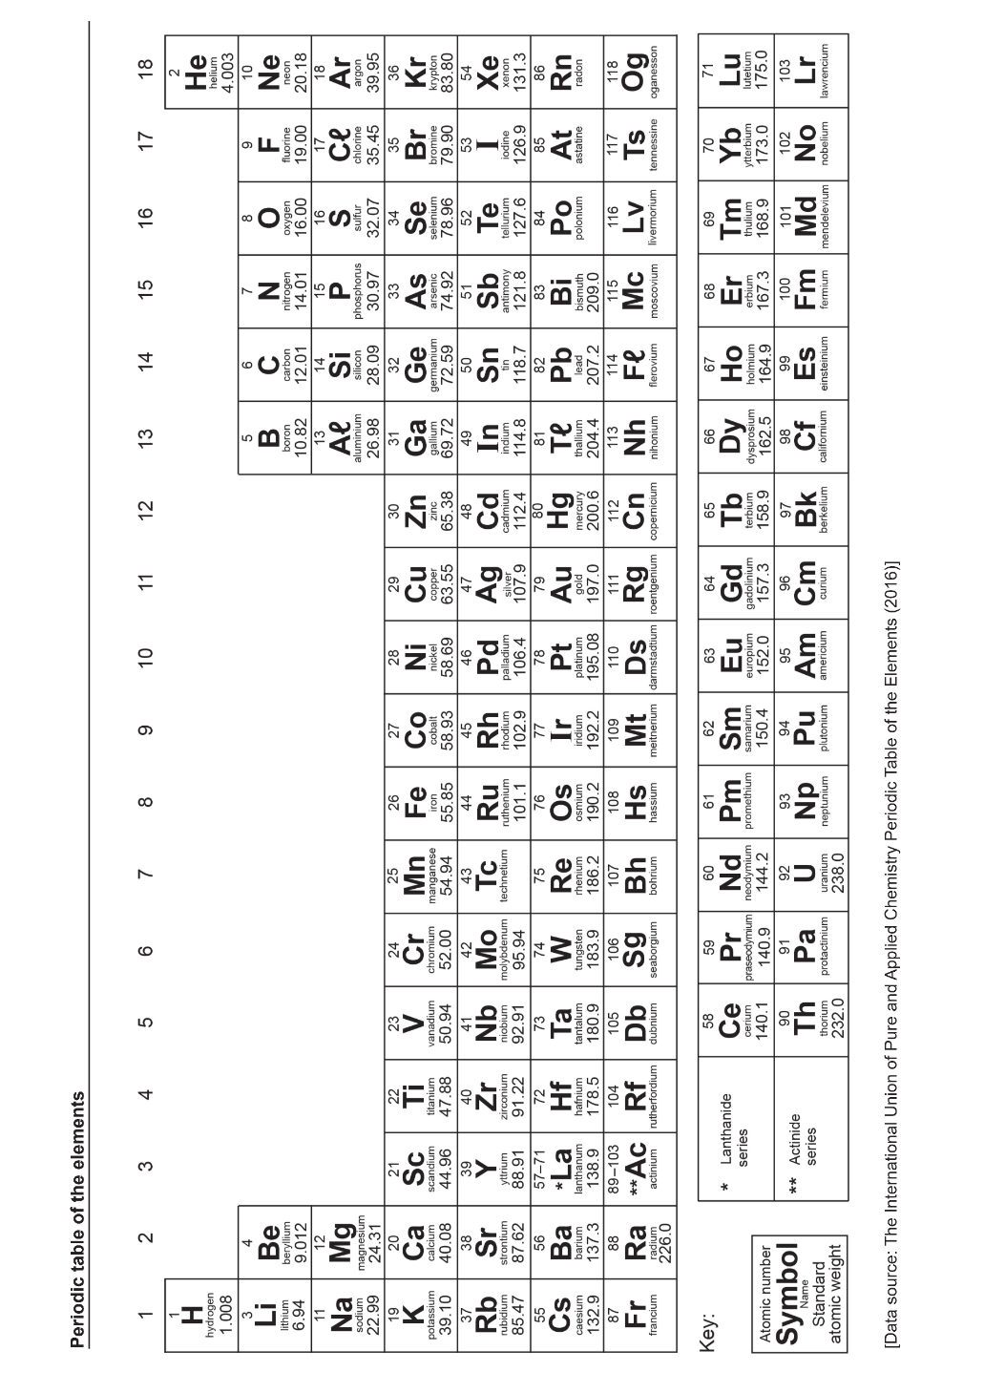Group 18 elements are known as noble gases
* H, N, O, F, Cl, Br and I are diatomic (exist naturally as a molecule of 2 atoms)
* Only Hg and Br are liquids at room temperature
* Elements with no mass number are always radioactive
* Elements 95+ do not occur naturally in the universe

Al

B

Ca

Mg

K

Na

Li

Be

H

Transition

Metals

Ar

Ne

Cl

F

S

O

P

N

Si

C

He

## Ions

Most atoms will easily gain or lose electrons to obtain a full outer (valence) shell. This movement of electrons is the basis of most chemical reactions.

* **Anions**: non-metals will typically gain electrons to fill up their outside shell, they will end up with more electrons than protons so they will be negatively charged
* **Cations:** metals will typically lose the electrons in their outside shell, leaving the next shell down full, they will end up with more protons than electrons so they will be positively charged

When an ion is written, its charge is noted in superscript after the symbol.

e.g. calcium ion: Ca2+

|  |  |  |  |  |  |  |
| --- | --- | --- | --- | --- | --- | --- |
|  | Species | Cation or Anion | Atomic number (#p) | Number of electrons | Number of neutrons | Mass number (#p+#n) |
| a |  | cation | 13 | 10 | 13 | 26 |
| b |  | anion | 15 | 18 | 16 | 31 |
| c |  | anion | 17 | 18 | 18 | 35 |
| d |  | cation | 3 | 2 | 4 | 7 |
| e |  | neither | 8 | 8 | 8 | 16 |
| f |  | anion | 8 | 10 | 8 | 16 |
| g |  | neither | 18 | 18 | 22 | 40 |
| h |  | cation | 12 | 10 | 12 | 24 |

|  |  |  |  |  |  |  |
| --- | --- | --- | --- | --- | --- | --- |
| Electrons | 4 | 18 | 47 | 6 | 10 | 35 |
| Neutrons | 5 | 18 | 60 | 6 | 14 | 44 |
| Protons | 4 | 17 | 47 | 6 | 13 | 35 |
| Mass number | 9 | 35 | 107 | 12 | 27 | 79 |
| Atomic number | 4 | 17 | 47 | 6 | 13 | 35 |
| Species |  |  |  |  |  |  |

|  |  |  |  |  |
| --- | --- | --- | --- | --- |
| Electron configuration | (2,8,1) | (2,8,8)  2-  O | (2,8)  Cl  - | (2,8,8)  S  2- |
| Shell diagram | Na | Ca  2+ |  |  |
| Electrons | 11 | 18 | 10 | 18 |
| Neutrons | 12 | 20 | 8 | 18 |
| Protons | 11 | 20 | 8 | 17 |
| Mass number | 23 | 40 | 16 | 35 |
| Atomic number | 11 | 20 | 8 | 17 |
| Species |  |  | O2- |  |

|  |  |  |  |  |  |  |  |
| --- | --- | --- | --- | --- | --- | --- | --- |
| Lewis diagram | P  3- | P | Mg  K  + |  | Li  + | How to Draw a Lewis Dot Structure: A Complete Guide  B |  |
| Electron configuration | (2,8,8) | (2,8,5) | (2,8,2) | (2,8,8) | (2) | (2,3) | (2,8,8) |
| Electrons | 18 | 15 | 12 | 18 | 2 | 5 | 18 |
| Neutrons | 16 | 16 | 12 | 21 | 4 | 6 | 16 |
| Mass number | 31 | 31 | 24 | 40 | 7 | 11 | 32 |
| Atomic number | 15 | 15 | 12 | 19 | 3 | 5 | 16 |
| Charge | -3 | 0 | 0 | +1 | +1 | 0 | -2 |
| Species |  |  |  |  |  |  |  |

## Element puns

Match the elements with the pun

|  |  |  |  |  |  |
| --- | --- | --- | --- | --- | --- |
| Argon | Caesium | Erbium | Krypton | Oxygen | Sulfur |
| Arsenic | Cerium | Europium | Lead | Radon | Tin |
| Barium | Copper | Holmium | Mercury | Rhodium | Tungsten |
| Boron | Curium | Indium | Neon | Scandium | Zinc |
| Bromine | Einsteinium | Iron | Neptune | Silicon | Zirconium |

|  |  |  |
| --- | --- | --- |
| 1 |  | Not an exciting person |
| 2 |  | What you do to a wrinkled shiurt |
| 3 |  | Superman’s weakness |
| 4 |  | My brother |
| 5 |  | Extinct |
| 6 |  | What a dog does with its bone |
| 7 |  | What a doctor does to a male patient |
| 8 |  | A place for washing dishes |
| 9 |  | E=mc2 |
| 10 |  | Get him |
| 11 |  | Imitation diamond |
| 12 |  | How to catch a horse |
| 13 |  | A silly convict |
| 14 |  | Sinker material |
| 15 |  | What I did at the rodeo |
| 16 |  | A place for growing herbs? |
| 17 |  | Hug me |
| 18 |  | Make sure my steak is well cooked |
| 19 |  | The police raid is a goer! |
| 20 |  | A cowboy’s foe |
| 21 |  | Attaching a leg joint |
| 22 |  | A policeman |
| 23 |  | Part of the mouth that tastes |
| 24 |  | Stewed beef again! |
| 25 |  | The animal coat is sold |
| 26 |  | Roman god of the sea |
| 27 |  | Deliberately lighting fires. Has a hiccup/ |
| 28 |  | A cry for compassion |
| 29 |  | A metal container |
| 30 |  | Disgrace, shameful |

